HOW TO INSTALL

1. Create your class in SE24

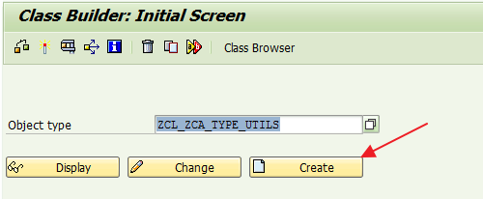

1. Click on **Source Code Based** button

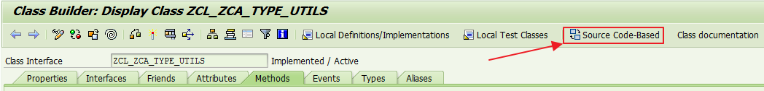

1. Paste the code, just overwrite all the code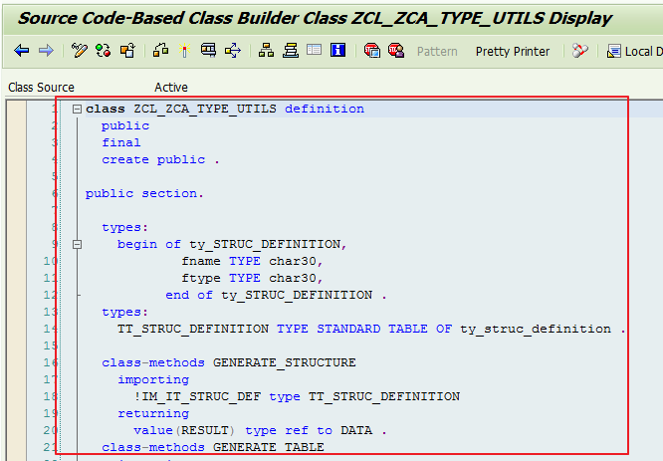
2. Activate and Save. Do the same thing with the rest of the class